Test Case 1

1. University Scholarship Allocation
1.Problem Statement
To develop a Python program that checks students' marks, subject scores, attendance, and family income to determine scholarship eligibility and rank eligible students.
2.Algorithm
- Start the program.
- Read student details.
- Check marks, subject score, attendance, and income.
- Select eligible students.
- Rank students by aggregate marks; break ties using attendance.
- Display the ranking and stop.
3.Flowchart
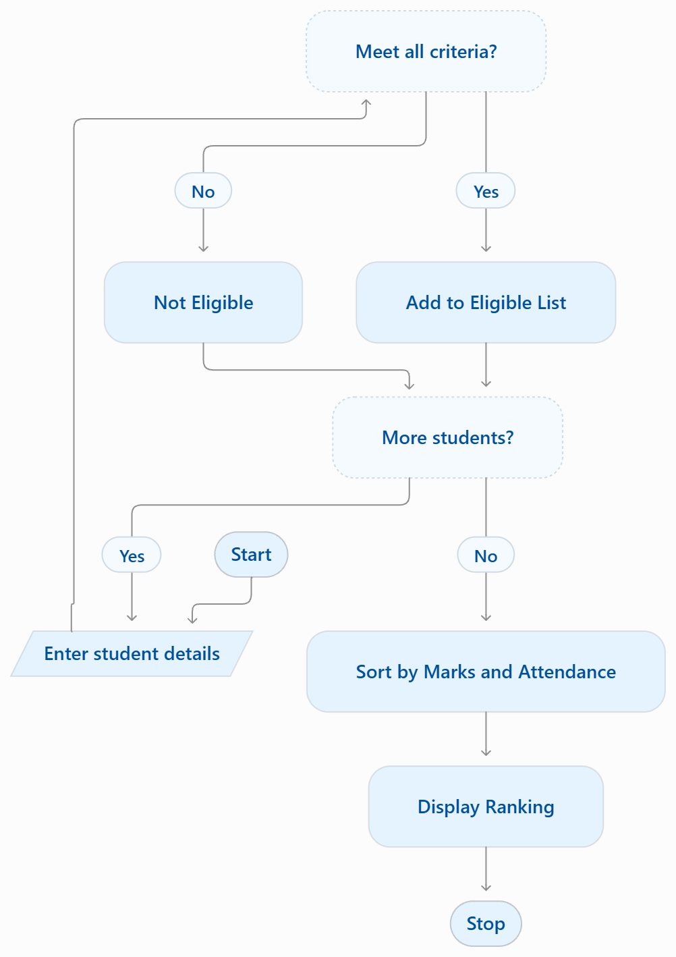
4.source code

n = int(input("Number of students: "))
students = []

for i in range(n):
name = input("Name: ")
marks = float(input("Aggregate marks: "))
subject = float(input("Minimum subject score: "))
attendance = float(input("Attendance %: "))
income = float(input("Family income: "))

if marks >= 75 and subject >= 40 and attendance >= 75 and income <= 200000:
students.append((name, marks, attendance))

students.sort(key=lambda x: (-x[1], -x[2]))

print("\nScholarship Ranking:")
for rank, s in enumerate(students, 1):
print(rank, s[0], "Marks:", s[1], "Attendance:", s[2])

if not students:
print("No eligible students.")

5.Sample Input
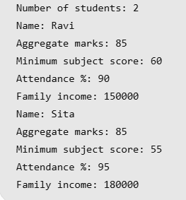
6.Sample Output
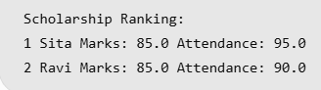

Test Case 2

11. Examination Result and Grace-Mark Validation
1. Problem Statement
To process subject marks, apply grace marks if needed, check pass criteria, and display the final result and classification without exceeding maximum marks.
2. Algorithm
- Read marks of three subjects.
- Apply grace marks if required.
- Check pass marks for each subject.
- Display total, result, and classification.
3. Flowchart
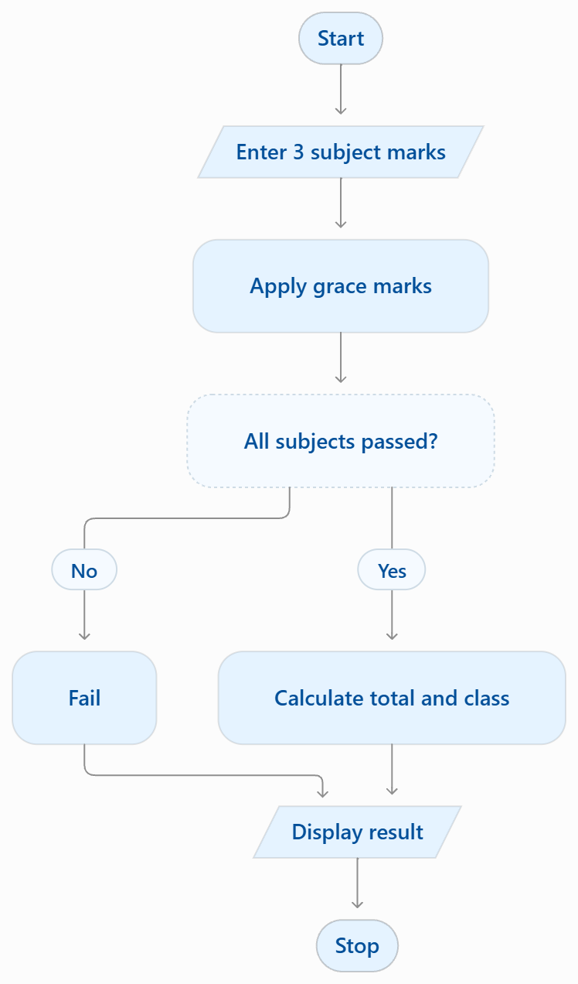
4.source code
marks = list(map(int, input("Enter 3 marks: ").split()))

for i in range(3):
if marks[i] == 34:
marks[i] = min(35, marks[i] + 1)

total = sum(marks)

if min(marks) < 35:
result = "Fail"
elif total >= 240:
result = "Distinction"
elif total >= 180:
result = "First Class"
else:
result = "Pass"

print("Marks:", marks)
print("Total:", total, "/ 300")
print("Result:", result)
5.Sample Input
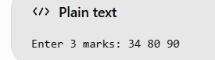
6. Sample Output
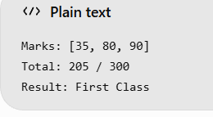

Test Case 3

21. Traffic Violation Penalty Calculator
1. Problem Statement
Calculate traffic fines based on vehicle category, offence type, and repeat offences. Identify whether the driver is disqualified.
2. Algorithm
- Read vehicle category, offence, and repeat status.
- Select the fine amount.
- Double the fine for repeat offences.
- Display the total penalty and disqualification status.
3. Flowchart
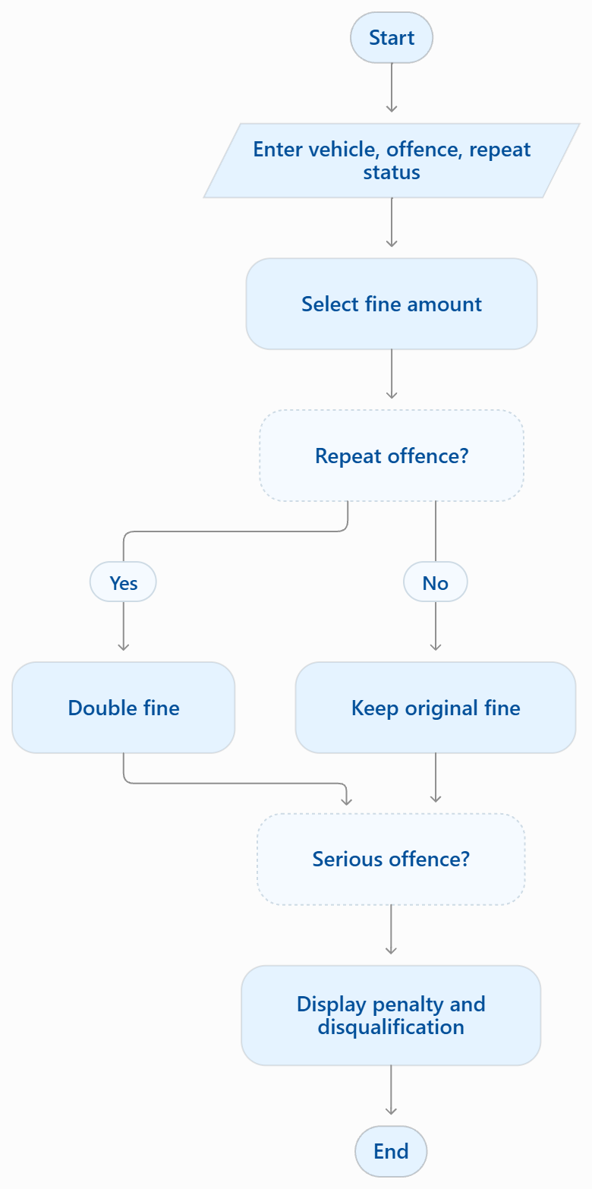
4.source code
fine = {"Car": 1000, "Bike": 500, "Truck": 2000}

v = input("Vehicle (Car/Bike/Truck): ")
o = input("Offence (Normal/Serious): ")
r = input("Repeat (yes/no): ")

penalty = fine.get(v, 0)
if r == "yes":
penalty *= 2

print("Penalty: ₹", penalty)
print("Disqualification:", "Yes" if o == "Serious" else "No")

5.Sample Input
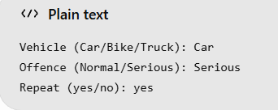
6. Sample Output
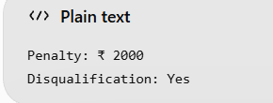

Test Case 4

31. String-Based Examination Answer Evaluation
1. Problem Statement
Compare student answers with the answer key, calculate correct, incorrect, and unanswered responses, apply negative marking, and display the final result.
2. Algorithm
- Start.
- Read the answer key and student answers.
- Count correct, incorrect, and unanswered answers.
- Apply negative marking for incorrect answers.
- Display the final score.
- Stop.
3. Flowchart
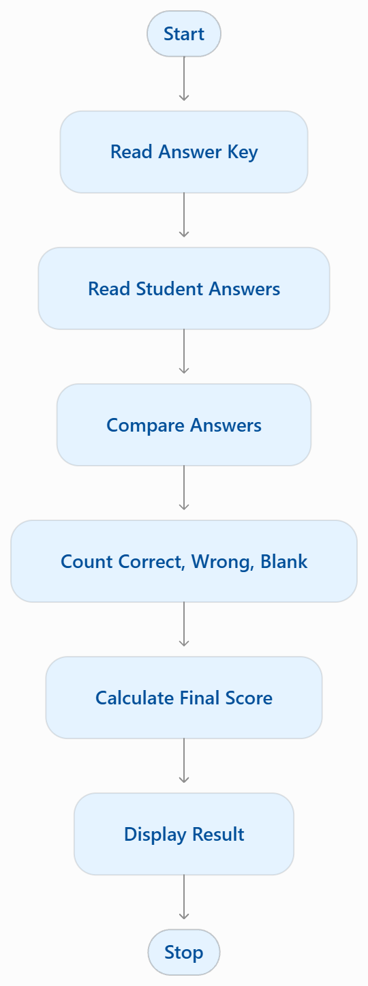
4.source code
key = input("Answer key: ").split()
ans = input("Student answers: ").split()

c = w = u = 0
for k, a in zip(key, ans):
if a == "-":
u += 1
elif a == k:
c += 1
else:
w += 1

score = c - w * 0.25
print("Correct:", c, "Wrong:", w, "Unanswered:", u)
print("Final Score:", score)

5.Sample Input
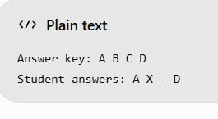
6. Sample Output
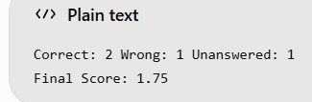

Test Case 5

41. Nested List Classroom Occupancy Analysis
1. Problem Statement
Represent classrooms using nested lists, allocate students, preserve reserved seats, detect duplicate assignments, and calculate vacant seats.
2. Algorithm
- Create a nested list of classroom seats.
- Allocate students to available seats.
- Preserve reserved seats.
- Check duplicate student names.
- Display vacant seat count.
3. Flowchart
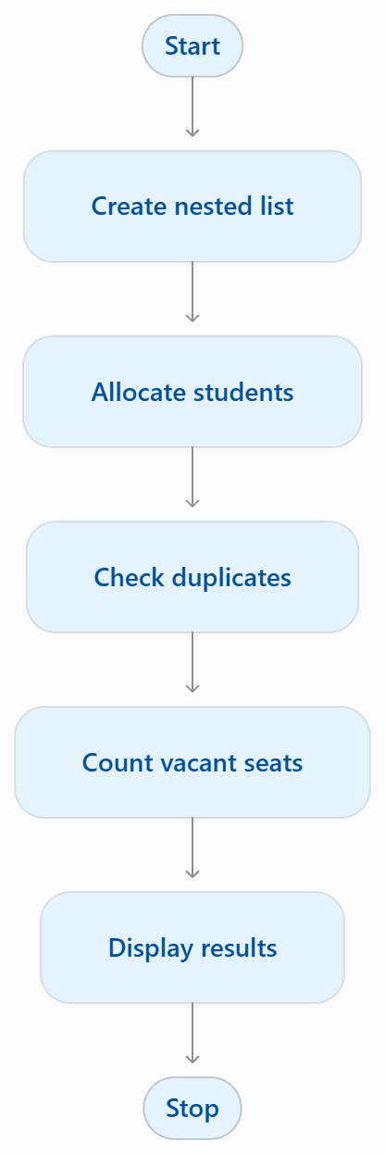
4.source code
rooms = [["Ram", "Reserved", None],
["Sita", "Ram", None]]

students = [s for room in rooms for s in room
if s not in (None, "Reserved")]

print("Duplicate:", len(students) != len(set(students)))
print("Vacant seats:", sum(s is None for r in rooms for s in r))

5.Sample Input
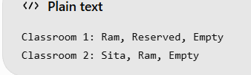
6. Sample Output
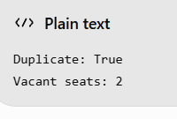

Test Case 6

51. Bus Passenger Occupancy Simulation
1. Problem Statement
To calculate passenger counts at each bus stop using boarding and alighting numbers and check whether bus capacity is exceeded.
2. Algorithm
- Read bus capacity and number of stops.
- Read boarding and alighting counts.
- Calculate current passengers.
- Display passenger count and capacity status.
3. Flowchart
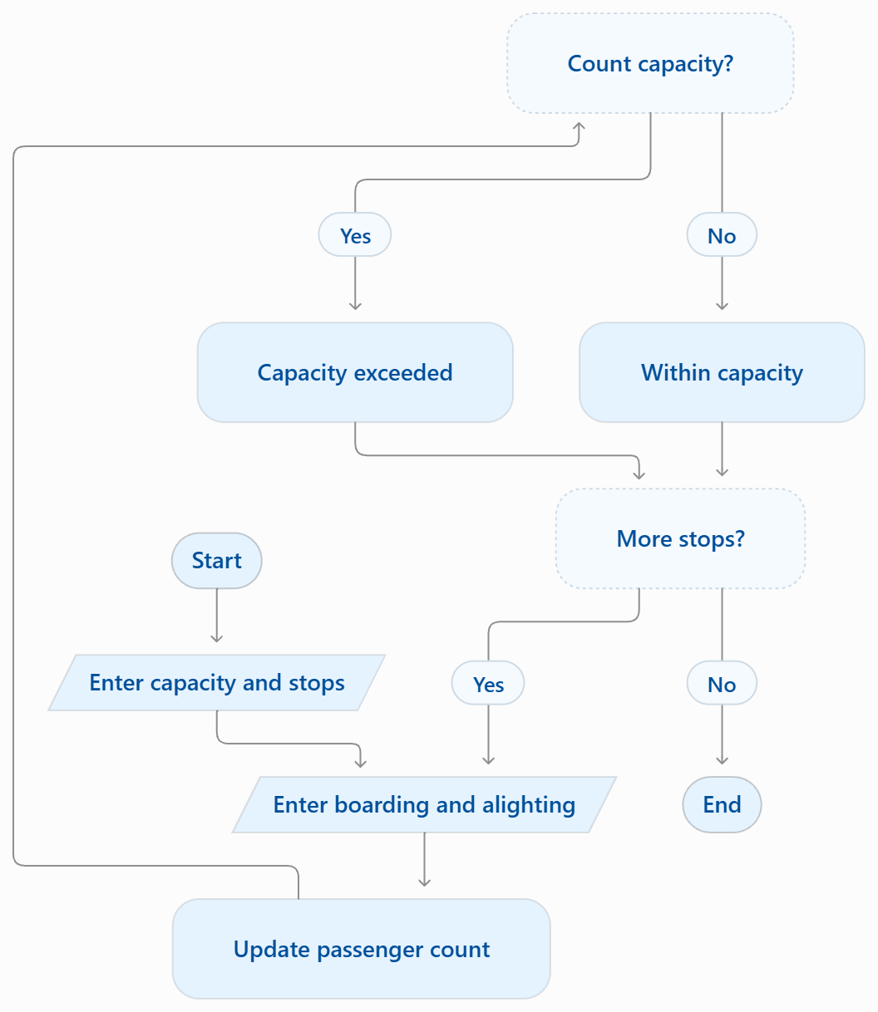
4.source code

cap = int(input("Bus capacity: "))
n = int(input("Number of stops: "))
p = 0

for i in range(n):
b = int(input("Boarding: "))
a = int(input("Alighting: "))
p = max(0, p - a) + b
print("Passengers:", p)
print("Capacity exceeded" if p > cap else "Within capacity")
5.Sample Input
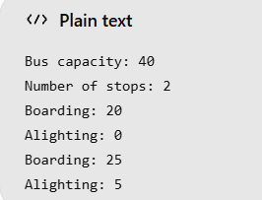
6. Sample Output
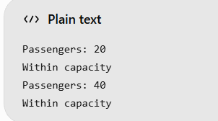

Test Case 7

61. Nested List Examination Seating Validation
1. Problem Statement
Validate the seating matrix for duplicate roll numbers, reserved seats, empty seats, and invalid student allocations.
2. Algorithm
- Store seats in a nested list.
- Check each seat for reserved, empty, or invalid values.
- Find duplicate roll numbers.
- Display the validation results.
3. Flowchart
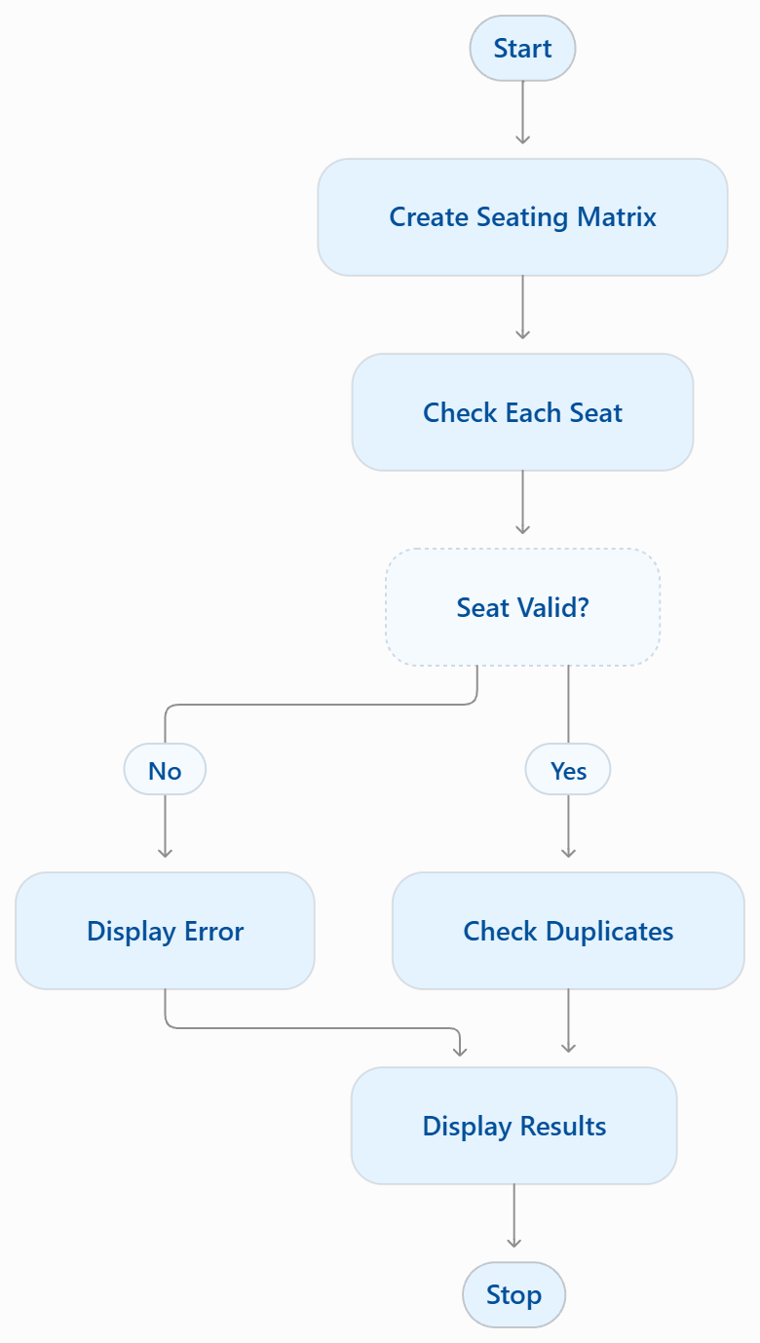
4.source code

seats = [[101, 102], [103, 101]]
reserved = [(0, 1)]
seen = []

for i, row in enumerate(seats):
for j, s in enumerate(row):
if (i, j) in reserved:
print(s, "Reserved seat occupied")
elif s == 0:
print("Empty seat")
elif s < 0:
print("Invalid allocation")
elif s in seen:
print(s, "Duplicate roll number")
else:
seen.append(s)
print(s, "Valid")
5.Sample Input
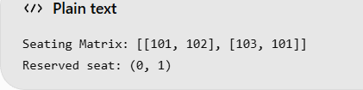
6. Sample Output
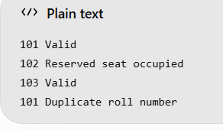

Test Case 8

71. Integrated University Fee and Eligibility Audit
1. Problem Statement
To check students' fee payments, attendance, and internal marks to determine examination eligibility and report pending conditions.
2. Algorithm
- Start.
- Enter student details.
- Check fees, attendance, and marks.
- Display pending conditions or eligibility.
- Stop.
3. Flowchart
4.source code

seats = [[101, 102], [103, 101]]
reserved = [(0, 1)]
seen = []

for i, row in enumerate(seats):
for j, s in enumerate(row):
if (i, j) in reserved:
print(s, "Reserved seat occupied")
elif s == 0:
print("Empty seat")
elif s < 0:
print("Invalid allocation")
elif s in seen:
print(s, "Duplicate roll number")
else:
seen.append(s)
print(s, "Valid")
5.Sample Input
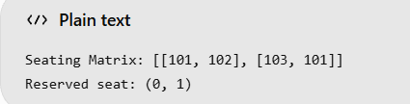
6. Sample Output
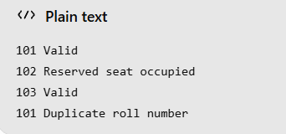

Test Case 9

81. Campus Event Seating and Entry Validation
1. Problem Statement
To assign seats using nested lists, validate tickets, detect duplicate entries, and calculate available seats.
2. Algorithm
- Create a seating list and registration IDs.
- Read ticket IDs.
- Check valid and duplicate tickets.
- Assign seats and count available seats.
- Display the results.
3. Flowchart
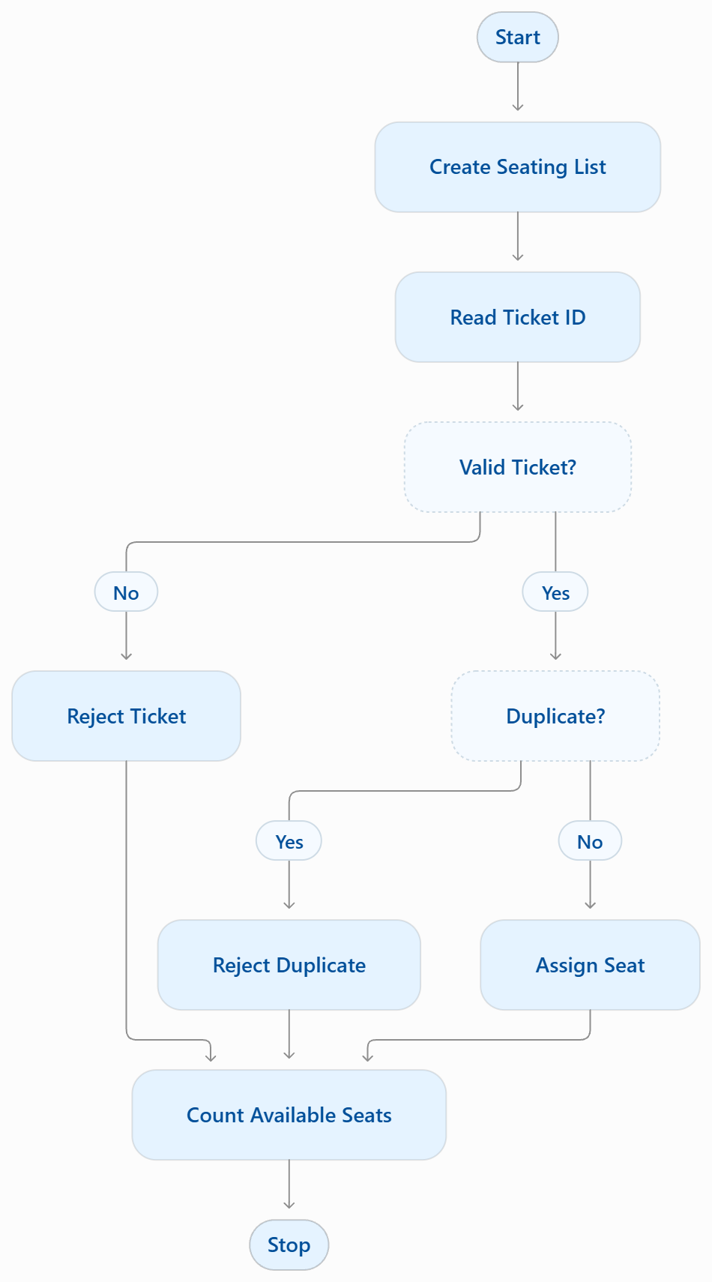
4.source code
seats = [[None, None], [None, None]]
registered = ["A1", "A2", "A3"]
entered = []

for ticket in ["A1", "A2", "A1", "X1"]:
if ticket not in registered:
print(ticket, "Invalid")
elif ticket in entered:
print(ticket, "Duplicate")
else:
entered.append(ticket)
for row in seats:
if None in row:
row[row.index(None)] = ticket
print(ticket, "Seat assigned")
break

print("Available seats:", sum(r.count(None) for r in seats))
5.Sample Input
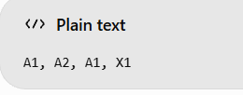
6. Sample Output
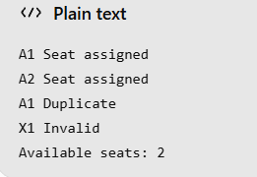

Test Case 10

91. Advanced String-Based Registration Record Analyzer
1. Problem Statement
To validate registration strings, check field formats and lengths, extract details, detect duplicates, and display errors.
2. Algorithm
- Read registration records.
- Split each record into fields.
- Validate field lengths and formats.
- Check duplicate IDs.
- Display valid records and errors.
3. Flowchart
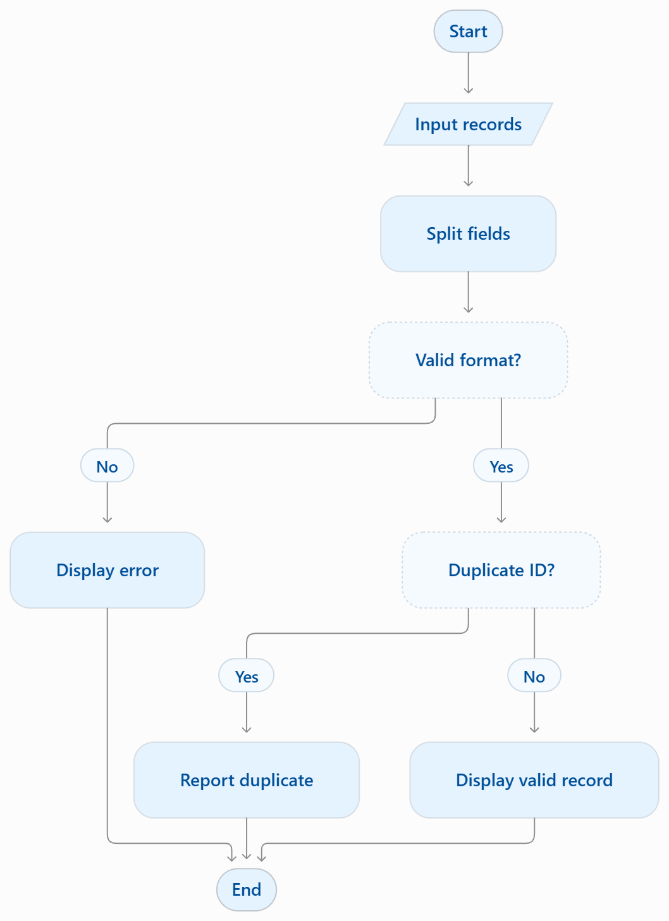
4.source code
records = input("Enter records: ").split(";")
seen = set()

for r in records:
f = r.split(",")
if len(f) != 3 or len(f[0]) != 4 or not f[1].isalpha():
print(r, "- Invalid format")
elif f[0] in seen:
print(r, "- Duplicate ID")
else:
seen.add(f[0])
print("Valid:", f[0], f[1], f[2])
5.Sample Input
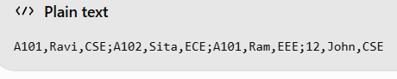
6. Sample Output
